How to update minikube latest version?

1) Check your current minikube version.

# minikube version



2) check your latest minikube version available to install or update.

# minikube update-check


here you will see LatestVersion v1.29.0, and that’s where we are planning to upgrade too.

3) Stop if your minikube cluster incase its running.

# minikube stop & then check the status of your minikube status.

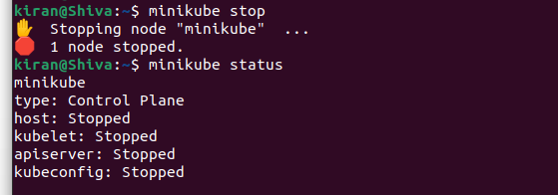

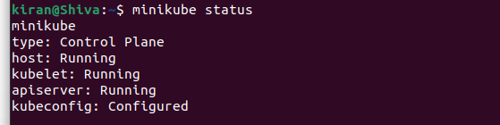

4) Delete your minikube cluster .

# minikube delete

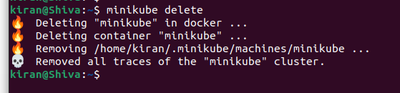

5) Remove minikube binary files from /usr/local/bin/minikube

Check -- # ls -ltr /usr/local/bin/minikube

Remove -- # sudo rm -rf /usr/local/bin/minikube

Verify -- # ls -ltr /usr/local/bin/minikube

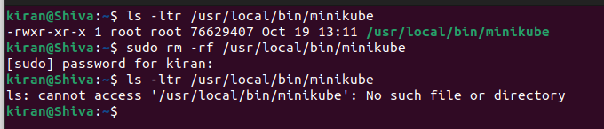

6) Download latest minikube binary from here Minikube Download

# curl -LO https://storage.googleapis.com/minikube/releases/latest/minikube-linux-amd64

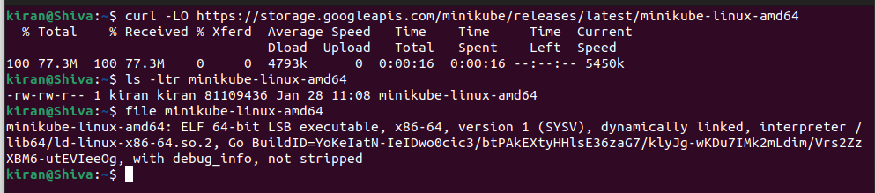

7) After downloading Install minikube.

# sudo install minikube-linux-amd64 /usr/local/bin/minikube

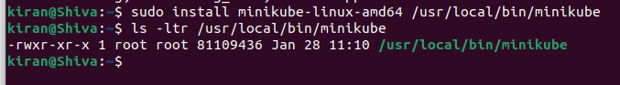

& that’s it we have installed and upgraded our minikube cluster successfully. Whoooo Hoooooo !!!

Verify the status with below command.

# minikube version

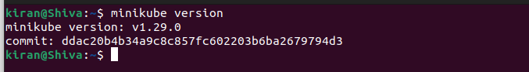

8) Start your minikube cluster.

Note :- This will take some time to pull base kubernetes v1.26.1 images to start your minikube cluster.

# minikube start

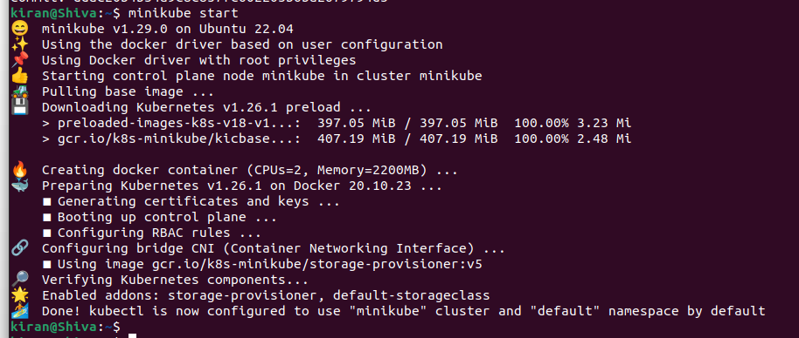

9) check the status of your minikube cluster.

# minikube status

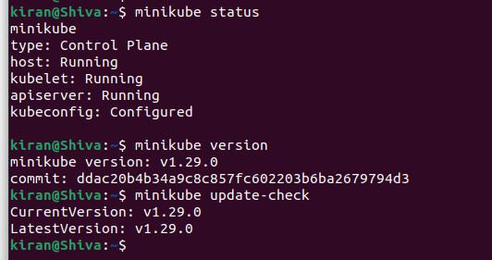

Happy Learning

